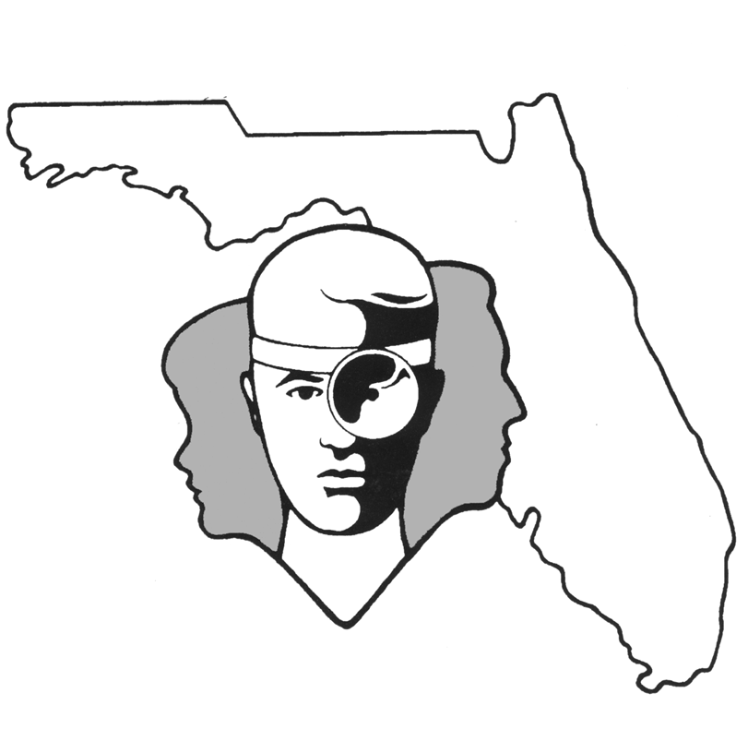
TALLAHASSEE EAR, NOSE & THROAT - HEAD & NECK SURGERY, P.A.

www.TallyENT.com (850)877-0101

SEPTOPLASTY with or without TURBINATE REDUCTIONS

Your surgeon has recommended to you that you undergo a procedure called a septoplasty. Basically, this involves straightening a structure within your nose called a septum, which divides the nose into a right and left half. The portion of the septum toward the front of the nose is made up of cartilage similar to the cartilage that makes up your outer ear, and the back part of the septum is made up of bone. Presumably your surgeon has recommended this procedure to you because either the cartilage and/or the bony portions of your septum are crooked and are now blocking one or both sides of your nasal airway.

A septoplasty is designed to either straighten the bone or cartilage such that it will be back in the middle of the nose, or actually to remove the portions which are crooked and leave the straight portions behind. The surgical procedure itself is done intranasally with no incisions made out on the face. Occasionally, we will do what is called an external septoplasty where a small incision is made on the undersurface of the nose, where it would be relatively unnoticeable. After the incision is made, usually up inside the nose on one side, the lining tissue of the nose is separated from the underlying cartilage and lifted up as a flap. Once the cartilage and bone are exposed, the portions which are deviated are straightened or removed. Once the septum is placed back into the middle of the nose, a stitch is placed through and through the septum to bring back the lining tissue into close contact with the underlying cartilage. When the septum is particularly crooked, nasal splints are sometimes placed for up to one week to maintain the straightened septum in the midline.

There are several potential complications of septoplasty, but they are all very uncommon and over 99% of the time this procedure occurs without any particular complication. Some of the potential problems which might arise could include potential bleeding from the surgery. There are a lot of blood vessels into the nose, and there is always the chance that one of them will bleed postoperatively, particularly if you strain or do any heavy lifting or exercise. Sometimes, if the supportive lining tissues on either side of the septum are torn, and if the underlying cartilage is damaged, there is the potential that there will be a hole that develops between the right and left sides of the nose through the septum. Generally, these do not cause symptoms, but occasionally can cause problems with crusting around the edge of the perforation, bleeding, or sometimes a whistling sound as you breathe through the nose.

As in any surgery, there is always the risk of an infection and, particularly in the nose; there is the risk of severe infections, especially if packing is used. The same types of organisms that can infect tampons and cause toxic shock may also infect nasal packing and cause a similar severe infection. Sometimes a lesser infection may still be a problem if it causes erosion of the cartilage and subsequent loss of some support to the nose. If too much of the cartilage is reabsorbed due to an infection or removed excessively during the procedure, then the support to the nose can be weakened, and the lower half of the nose may tend to collapse inward.

One additional procedure that your surgeon may recommend along with the septoplasty is reduction of your nasal turbinates. These are the structures that heat and humidify air as you breathe it into your nose. They hang down from the side walls of your nose into the nasal passageway, and these are what tend to swell and shrink due to things such as colds, weather changes, or allergies. Sometimes these have to be surgically reduced in size because they have gotten to the point where they stay enlarged and thereby obstruct your nasal airway.

Because bleeding is a risk, we ask that you not take aspirin-containing products (example: B.C. or Goody’s headache powders, Anacin, baby aspirin, etc.) for at least two weeks prior to your surgical procedure.
In addition, we would like you to discontinue any herbal supplements you take the week before surgery. Avoid the use of AFRIN or any nasal decongestant nose spray for 14-21 days prior to SINUS or NASAL surgeries.

The important thing to keep in mind as you are considering this operation is that even though it does have a number of potential complications, they are all exceedingly rare. In general, over 80% of people who undergo this surgery have a marked improvement of their nasal airway, and the satisfaction level for this procedure is very high. We have a great deal of experience with this procedure, since it is one that we perform frequently.

